
Carsie Blanton
www.carsieblanton.com

Booking inquiries:
tyler@atomicmusicgroup.com

Free Download:
www.carsieblanton.com/music

Carsie Blanton is a singer/songwriter based in New Orleans. Her albums range from folk and pop (Buoy, 2009) through Americana and rock (Idiot Heart, 2012; Rude Remarks, 2013), to classic jazz (Not Old, Not New, 2014). Her live performances, which include material from every album, are praised for their wit, humor, and captivating charm.

Carsie has toured extensively throughout North America and Europe since 2006, as a headliner and as support for Paul Simon, The Wood Brothers, Loudon Wainwright III, The Weepies, Shawn Colvin and many more. In 2013, she raised over $60,000 on Kickstarter for the making of Not Old, Not New. In addition to four full-length albums and two EPs, she has gained popularity for her blog (which tackles questions of love and sexuality) and music videos (including Baby Can Dance and Backbone).

"It might seem counterintuitive for one of Americana’s best modern songwriters to take on the Great (Old) American Songbook… [but] rarely does a little something sound both so inviting and this deep—and, in relighting these songs with the warm glow of the Crescent City (“lazy” and “sleepy” get used a lot), Blanton gives them a new context: sexual liberation as a serious hobby."
- OffBeat Magazine on Not Old, Not New

"Carsie Blanton has hit one out of the park. The singer-songwriter's third album, "Idiot Heart," is funny. It's tender. It's cute. It's edgy. It's fresh. It's folksy without crossing into the realm of kitsch. The songs are clean, most with basic instrumentation and succinct arrangements, but each track bursts with its own pithy, poignant commentary on that ficklest of organs for which the album is named."
- The Washington Post on Idiot Heart

"[Rude Remarks & Dirty Jokes] reflects a strong, unabashed sense of self, one she backs up with smartly phrased,
well-observed lyrics and songs that show them and her voice to their best advantage."
- Alex Rawls, My Spilt Milk

"Carsie Blanton is a rare talent as a modern songwriter, her sly wit and urbane imagery reminds me
of a female Cole Porter. I'm happy to know that classic songwriting is in good hands with Carsie Blanton."
- John Oates (of Hall & Oates)

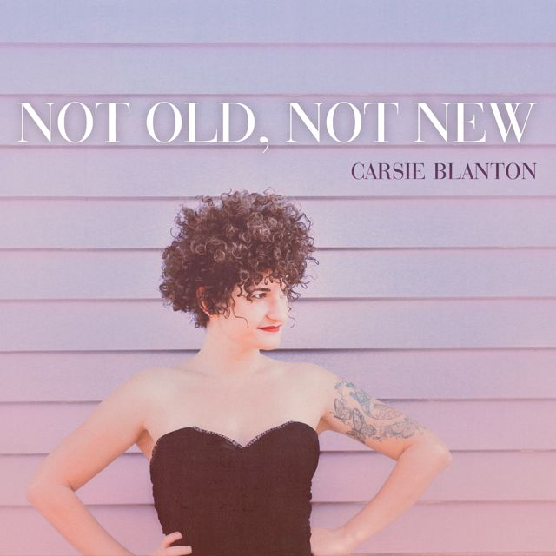
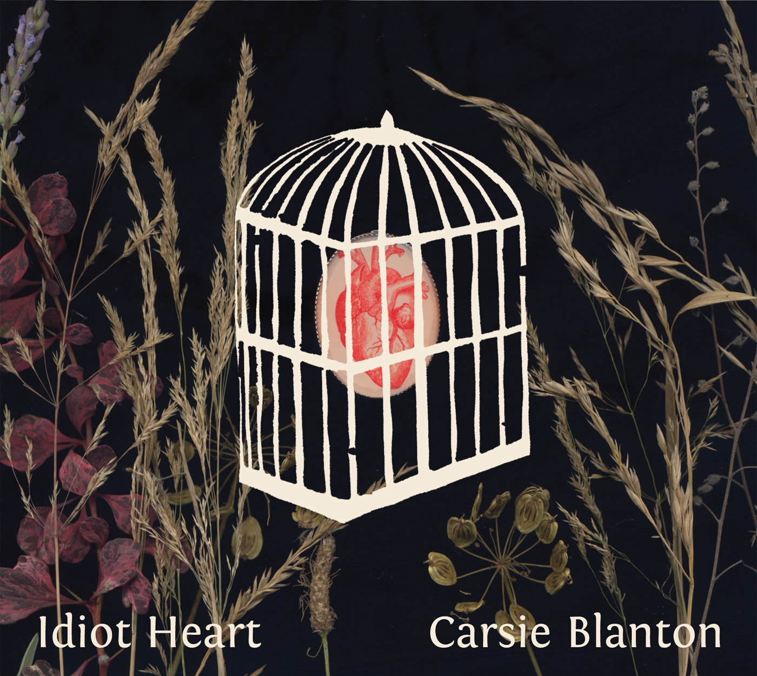
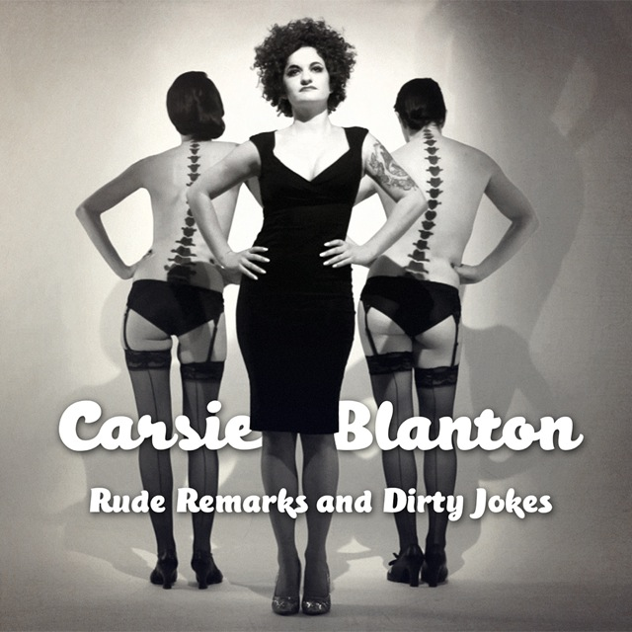
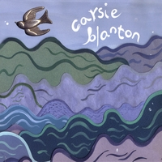

Download Carsie’s albums for free at www.carsieblanton.com/music.

Blog, music videos and more at www.carsieblanton.com.

